Medical RAG Assistant
AI-Powered Medical Question Answering System
Live URL: https://chatmedassist-production.up.railway.app

1. Purpose & Overview
The Medical RAG Assistant is a Web-based Generative AI and NLP application, designed to help healthcare professionals, medical students, and researchers quickly find accurate answers to clinical, diagnostic, and treatment questions. It leverages Retrieval-Augmented Generation (RAG) to ground its responses in authoritative medical literature rather than relying solely on a large language model’s training data.
The system is built on the Merck Manual of Diagnosis & Therapy (19th Edition), a comprehensive medical reference spanning over 4,000 pages and 23 clinical sections.

2. How It Works
The application follows a six-stage RAG pipeline that transforms a user’s natural language question into a grounded, context-aware answer:
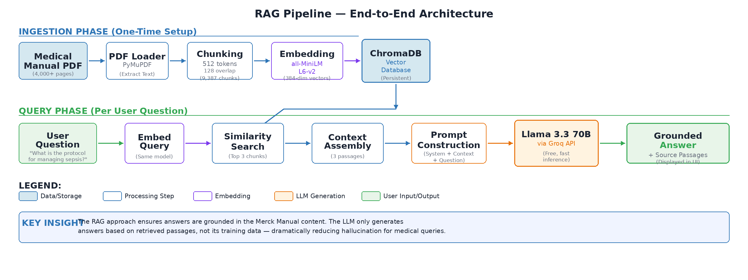
Step | Stage | Description
1 | PDF Loading | The Merck Manual PDF is loaded using PyMuPDFLoader, extracting text from all 4,000+ pages.
2 | Chunking | Text is split into 9,387 overlapping chunks of 512 tokens each (128-token overlap) using LangChain’s RecursiveCharacterTextSplitter.
3 | Embedding | Each chunk is converted into a 384-dimensional vector using the all-MiniLM-L6-v2 sentence transformer model.
4 | Vector Storage | All embeddings are stored in a ChromaDB vector database for fast similarity search.
5 | Retrieval | When a user asks a question, the top 3 most semantically similar chunks are retrieved.
6 | Generation | Retrieved context and the question are sent to Llama 3.3 70B (via Groq API) to generate a grounded answer.

3. Technical Architecture

Technology Stack
Component | Technology
Frontend | Custom HTML/CSS/JavaScript — responsive dark-themed chat interface
Backend API | FastAPI (Python) — async web framework with automatic OpenAPI documentation
PDF Processing | PyMuPDF via LangChain PyMuPDFLoader
Text Chunking | LangChain RecursiveCharacterTextSplitter (tiktoken cl100k_base encoding)
Embeddings | all-MiniLM-L6-v2 (SentenceTransformers, 384-dimensional vectors)
Vector Database | ChromaDB (persistent, file-based storage)
LLM | Llama 3.3 70B Versatile via Groq API
Hosting | Railway (Docker-based deployment)
Containerization | Docker (Python 3.11-slim base image)

4. Key Features
- Context-Grounded Answers — Responses are based exclusively on retrieved medical manual content, reducing hallucination and ensuring clinical accuracy.
- Source Transparency — Every answer includes the 3 source passages used, allowing users to verify and explore the original reference material.
- Fast Response Times — Groq’s LPU inference infrastructure delivers answers in 2–5 seconds, even for complex clinical queries.
- Beautiful, Accessible UI — A polished, dark-themed chat interface with sample questions, loading animations, and responsive design for desktop and mobile.
- Scalable Architecture — The API-based LLM approach minimizes local GPU/memory requirements on the hosting platform.

5. Sample Queries
The application is designed to answer a wide range of medical questions, including:
- What is the protocol for managing sepsis in a critical care unit?
- What are the common symptoms and treatments for pulmonary embolism?
- What are the diagnostic steps for suspected endocrine disorders?
- What are the effective treatments for sudden patchy hair loss?
- What treatments are recommended for traumatic brain injury?

6. Deployment & Access
The application is containerized using Docker and deployed on Railway’s Platform-as-a-Service. The deployment pipeline is fully automated: pushing code to GitHub triggers an automatic build and deploy cycle. The Groq API key is securely stored in Railway settings.
Live URL: https://chatmedassist-production.up.railway.app

Author: Satish Kalapatapu

